**CHARLES PROXY**

**1.Intro**

**What is Charles?**

Charles is a cross-platform HTTP proxy application written in Java that enables you to view all HTTP and SSL/HTTPS traffic between your laptop/mobile and the internet.

You can view all the requests, responses, HTTP headers and metadata. (eg. Cookies, caching and encoding information).

**What is HTTP proxy?**

An HTTP Proxy is a server that receives requests from your web browser and then makes the request to the Internet on your behalf. It then returns the results to your browser.

**Who is this useful for?**

Charles is useful for both Developers and Testers for monitoring requests and responses, debugging issues etc.

Charles has many other features which could be very useful to you. We are going to learn some of them in this tutorial series.

**How to Download and Install Charles?**

Charles can be downloaded from this link(<https://www.charlesproxy.com/download/>).

You can download Charles for Windows, Mac or Linux operating systems.

You will get the installation instructions on this link(<https://www.charlesproxy.com/documentation/installation/>).

**2. Setting up the Mobile device**

We should see how to configure Charles for an Android device in this article. (iOS too have the same steps)

**Pre-Condition**: Your device and your machine should be connected to the same WiFi.

Follow the below-mentioned steps:

**1. Find the IP address of your machine.**

Click here to know how to find the IP address of your machine.

**2. Once you have the IP address with you, open the Settings screen on your android device and follow these instructions:**

* Tap on WiFi to open WiFi settings. (Please note that your device should be connected to the same WiFi as your machine.)
* Long tap on your WiFi connection.
* You would see the following options.

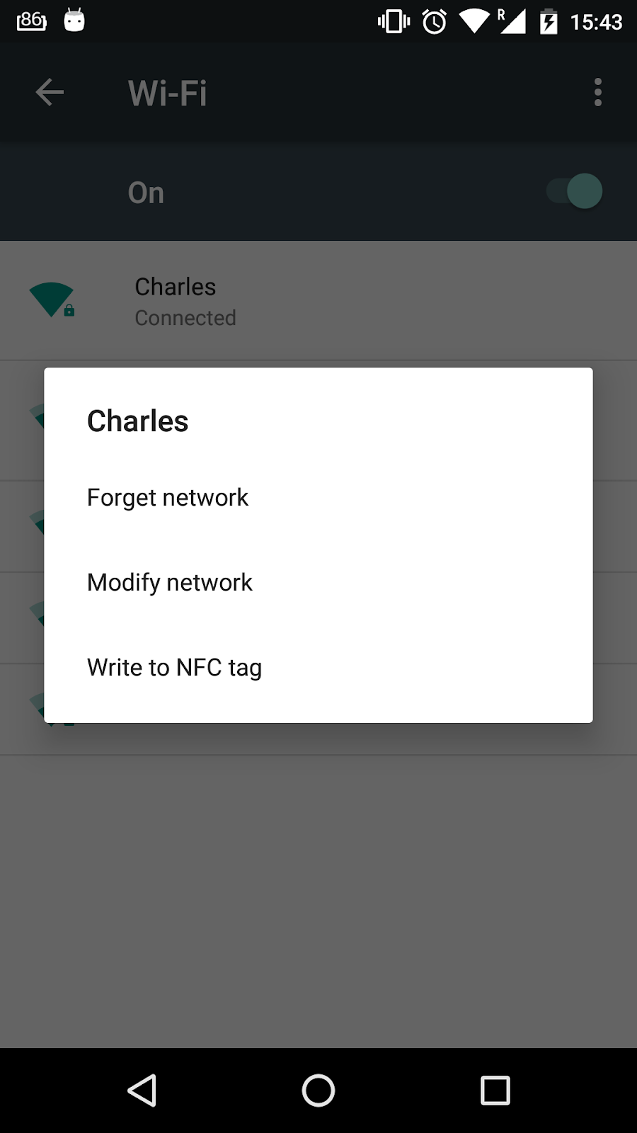

* Select option Modify network.
* Tap on Advanced options. You would see the below screen:

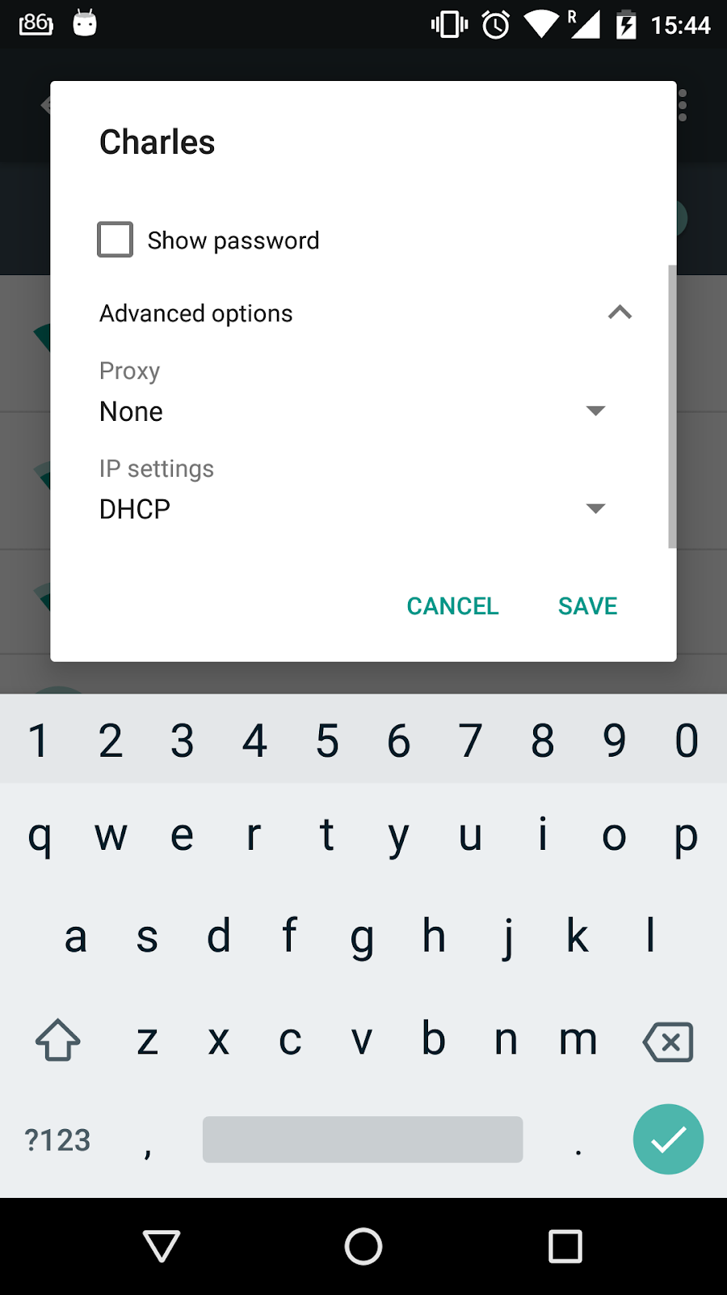

* Tap on the Proxy option and select Manual from the dropdown.
* Enter the IP address of your machine in the Proxy Hostname text field.
* Enter 8888 in the Proxy port text field. (8888 is the default post which Charles runs)
* After filling in the details your settings should look like this:

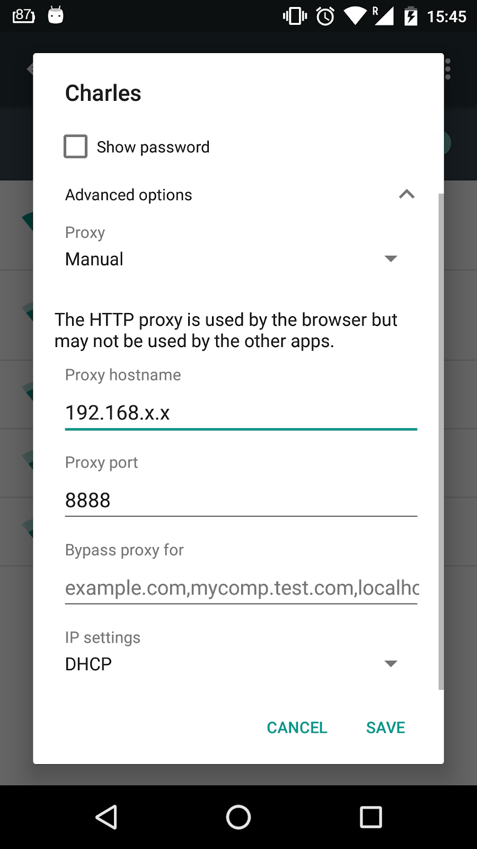

Tap on the Save button.

Your Wifi Setting is now configured. Next, you need a Charles certificate.

**Downloading Certificate:**

1. Launch Charles
2. Open your browser on an android device and type the URL <http://www.charlesproxy.com/getssl/>
3. You should see a prompt in Charles when you first make a connection from the device, asking you to allow the traffic.
4. The prompt should be shown by Charles with Allow and Deny buttons.

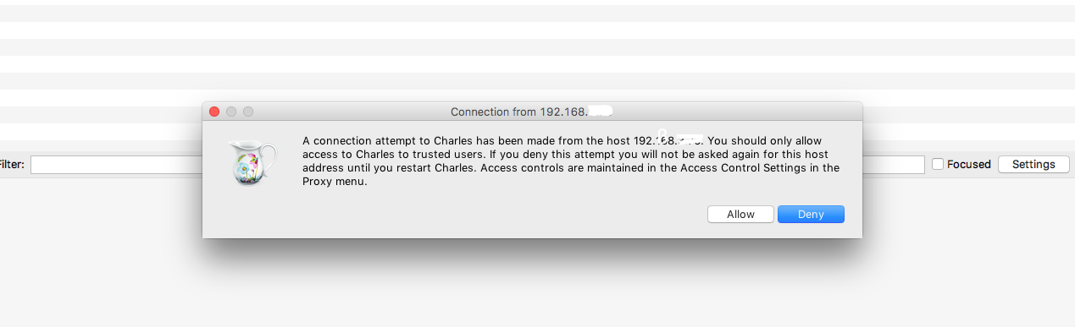

1. Click on the Allow button.
2. Hit enter. Charles proxy certificate file with .pem extension should get downloaded on your device.

**Installing the certificate.**

Tap on the file to install it and the certificate should get installed.

If you face trouble installing the certificate, follow these steps:

* Open device setting.
* Scroll to the Security setting and tap on it.
* Under Security settings, scroll to Install from storage and tap on it.
* You should be able to see the certificate under the Recent section in file explorer opened.
* Tap on the certificate.
* Enter the name of the certificate and tap on the OK button.

Here it is. Now the certificate is installed and you are all ready to start viewing your requests on Charles.

All of your web traffic from your Android/iPhone will now be sent via Charles.

Remember to disable the HTTP Proxy in your Settings when you stop using Charles, otherwise, you'll get confusing network failures in your applications!

**2a -Finding the IP address of your machine**

Here is how you can get the IP address of your machine :

**Windows:**

* Click the Start Menu, and select Run.
* Next, type ''cmd'' into the box and click the ''OK'' button.
* Finally, type ''ipconfig'' and information about your IP Address will be displayed at the prompt.

**Mac:**

1. Open your terminal, type the following command and hit enter:

* ifconfig | grep "inet " | grep -v 127.0.0.1
* Your IP address will be displayed next to the “inet” entry.

1. Open system preferences and click on Network. You can see your IP address on the right side of the window under the Status heading.

**Linux:**

Type ''ifconfig'' at the prompt, and it will output information about your IP Address.

**3. Understanding**

Let’s understand how to view/analyse requests in Charles.

There are two views in Charles.

**Structure View:**

Structure view lets you view the requests in a tree organised by the hostname and then folders/directories within the host

The below screenshot shows you a Structure view.

Observe that the hostnames are shown on the left and the details are shown on the right.

All hostnames have an arrow with them. Clicking on the arrow will show you the sub-folders/directories/requests.

To analyse a particular request click on it and the Request Viewer loads in the session window to show you the details.

If you want only a particular host to show up in the Structure view, you can use the Focus option. Learn more about the Focus option here.

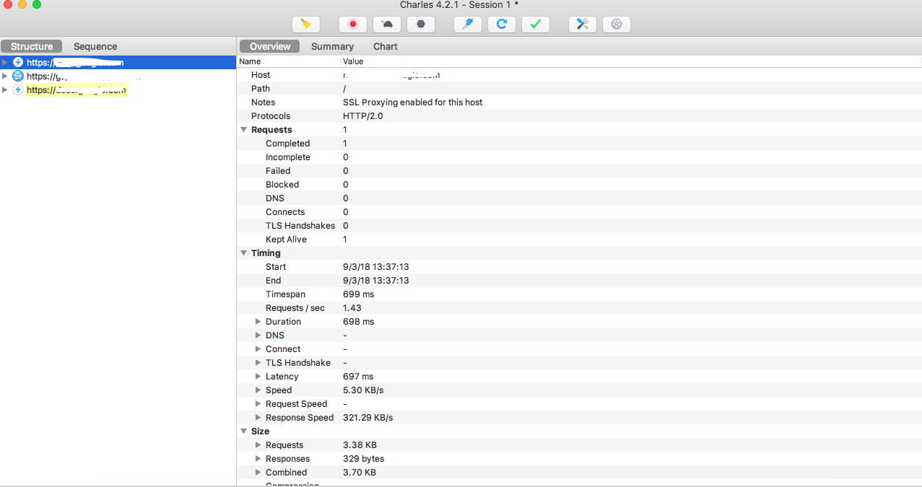

**Sequence View:**

Sequence view lets your view the requests in the sequence that they occur.

The below screenshot shows you a Sequence View.

There are three sections in a Sequence View.

The top view shows you the requests with details like Start time, Duration, Size, status etc. The middle view shows you the Requests details and the bottom view shows you the Response details.

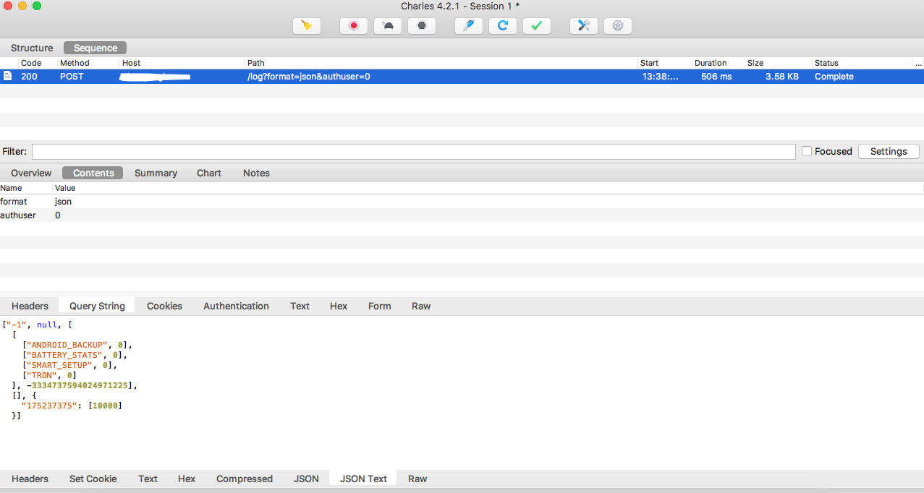

In the top bar menu, you could see Clear Current Session, Stop/Start Recording, Start/Stop Throttling, Enable/Disable Breakpoints, Compose a new request based on the selection, Repeat selected request, Validate selected response, Tools and Settings button.

We will study some of these menu options in upcoming articles.

**3a-Focus in Structure View**

### If you are using Structure view in Charles, you would see a lot of hosts cluttering up in the view. It becomes kind of difficult to focus on your hosts. Using the Focus feature, you can separate the hosts that you care about from the ones that you don’t.

To enable focus for a host, you need to right-click on the hostname in the Structure tree view and then choose the Focus option in the context menu.

### 

### 

### The Structure tree view will now show your focused host at the top, and then a folder named *Other Hosts*, which you can expand to see other hosts.

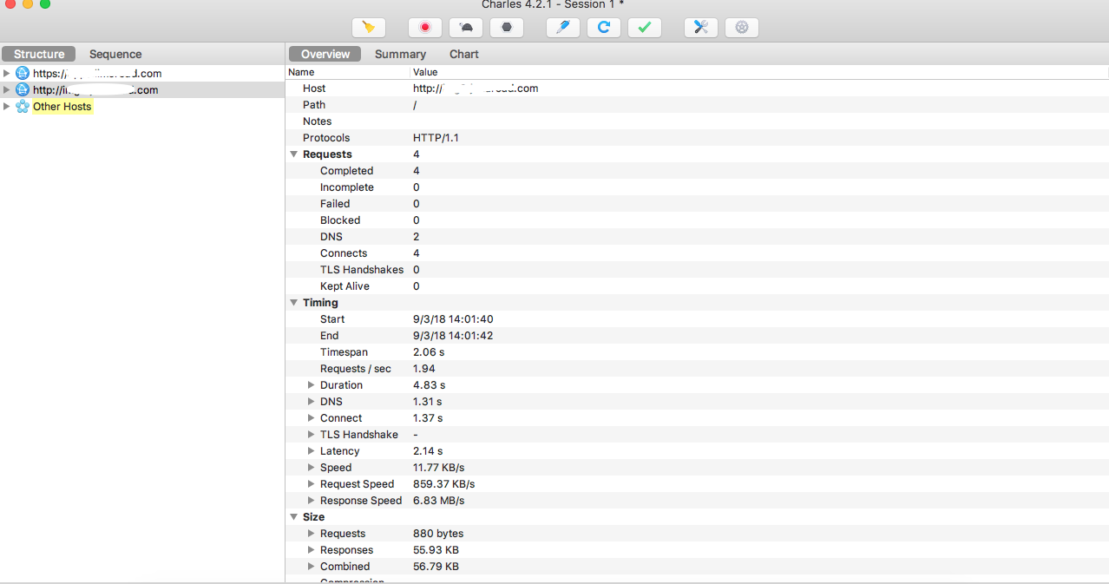

You can use the Focused checkbox in Sequence mode too to view requests only from focused hosts.

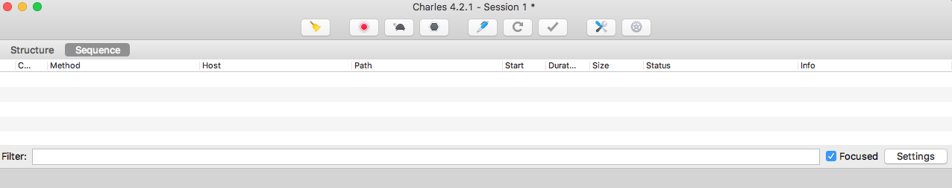

If you want to see the list of all your focused hosts, navigate to View Menu->Focused Hosts.

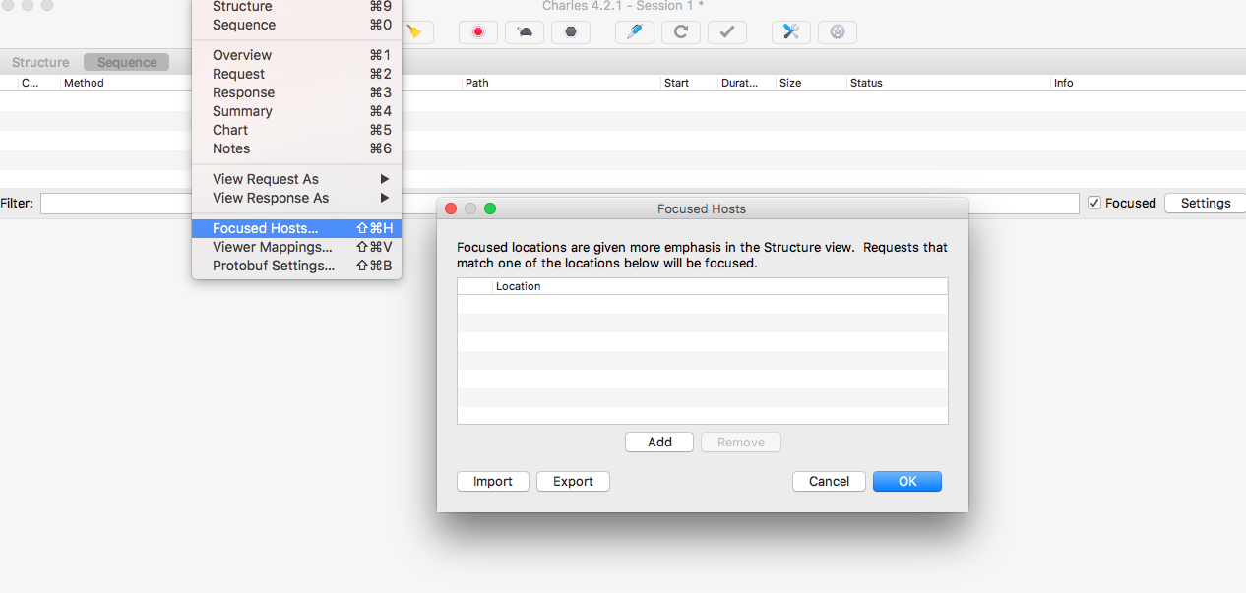

You can Edit/Remove/Add focused hosts from here.

**4-Using Breakpoints**

**What are breakpoints in Charles?**

Breakpoints are very useful functionality provided by Charles. You can analyze and edit any request or response before they are sent or received.

Before understanding how to use breakpoints in Charles, let us consider some use cases where we would need breakpoints and how we can benefit from them.

**Use Case:**

Suppose you are testing an e-commerce app/site where you see a COD option on the payment screen.

Now this COD option is based on a parameter say ‘isCODVisible’ which you receive in response to the call your app/site makes.

Whenever the option isCODVisible is True in response, the COD option is visible, and when isCODVisible is False, the COD option is not shown as a payment method on the screen.

**The Problem:**

Now in order to test this feature, you would change flags on the backend to receive true or false in the response and then check the visibility of the COD option.

This requires access to code, making changes in code, deploying changes.

Charles, on the other hand, makes it very easy to test this change without modifying any code.

**The Solution:**

Add a breakpoint to the response where you receive isCODVisible parameter.

Edit the response as per your need(True or False) and execute it.

There are many other use cases where Breakpoints in Charles are helpful.

a)Example when you have A/B tests running and you want to change the A/B test value for your request to test a specific case of A/B test.

b)Testing app/site UI with really long texts, no text etc. You can change the text in response and check how your UI is looking after changes.

c)Security testing.

I would leave it to you guys to read this tutorial and figure out what use case fits for you. Also as a task please mention your use case in comments so that other people could benefit too.

**How to use breakpoints :**

1. Perform the action on your site/app so that the API you want to add a breakpoint to, gets recorded to Charles.
2. Right-click on the request.
3. Select option Breakpoints. —>Breakpoint gets added to the API.

Lets now verify that the breakpoint is added in Breakpoints Settings.

To view/edit the Breakpoints setting, Click on Proxy->Breakpoints Settings.

You should be able to see the API call added to the Breakpoints Settings window. You can edit the breakpoint by double-clicking on the API.

**Edit Breakpoint Setting:**

You can change Scheme, Protocol, Host, Port, Path and Query from the edit Breakpoint settings.

Also, there is an option to edit either Request, Response or both.

Make relevant changes as per your requirement and save it.

Imp: Remove any query parameter from the edit breakpoint settings that might change with every request, otherwise breakpoint might not work properly.

You are all ready now to see the magic.

Perform the action again on your site/device.

As soon as the API gets called, you would see a Breakpoint window, with the call details (Request call or Response call as per the setting you saved) under Overview section and Edit Request/Response option.

Cancel, Abort and Execute buttons are visible at the bottom of the breakpoint window.

Click on Edit Request/Response, make necessary changes and tap on the Execute button to proceed.

Abort button blocks the request or response and sends an error message to the client.

The Cancel button discards any changes that you have made and lets the request or response proceed as if it wasn't intercepted.

**5-Throttling**

If you are developing or testing an application/website it is very important that you test its behavior in different network conditions.

Chances are that you are developing or testing the application in an environment with a good internet connection, but the end-user will have different internet connection speeds depending on the location/connection type(WiFi, 4g, 3g etc)

User experience can be tremendously impacted by your app’s behavior with different network conditions.

Charles helps you test your application in different network conditions using the Throttling option.

So let's learn how we can do this.

**What is Bandwidth Throttling?**

Bandwidth throttling is intentionally slowing down or speeding up the internet service.

**How can I turn On throttling option?**

1. Tap on the Throttling icon(Turtle icon) on the top toolbar.
2. Navigate to Proxy->Throttle Settings and check the option Enable Throttling.

The icon is greyed out if throttling is disabled and is in green colour if it’s enabled.

**Configuring Throttling settings.**

You can access the throttling setting under Proxy->Throttle Settings.

If you observe the Setting box it has the following options:

1. Turn ON throttle for selected hosts.
2. Throttle pre-set drop-down and other options.

You can set up your speed using the Throttle pre-set dropdown.

If you want to throttle only your own hosts, you can add them in the Turn ON throttle for selected hosts option.

Once you set Throttling settings as per your requirement and enable Throttling, it gets applied to all the requests or requests for hosts that are added in settings.

Now since you know about throttling, you can start testing your application in different network conditions.

Happy Testing!

**6-Map Remote Setting**

Often we face situations where we need to test our application in a test environment.

One of the solutions is to change code to point the application to a specific environment, create a new APK/IPA and then use it.

Map Remote setting in Charles saves your time and energy and lets you point your application to any host/port easily.

**Steps:**

1. Set up your mobile with Charles. (Click here to know how)
2. Launch Charles and click on Tools—>Map Remote option. —>Map Remote Settings opens up.
3. Click on Enable Map Remote checkbox to enable Remote Mapping.
4. Click on the Add button to add a mapping.
5. In the Map From section, enter the details of the current host, like Protocol, Host, Port etc.
6. In the Map To section, enter the details of the host you want to map to.
7. Click on the ‘OK’ button.
8. Click the ‘OK’ button on Map Remote Settings.
9. Now launch your app, and your app would be mapped to the new host now.

Eg: <https://charlesdocsy.com/2020/05/12/map-remote/>

**Important Links:**

1. <https://www.raywenderlich.com/22070831-advanced-charles-proxy-tutorial-for-ios#toc-anchor-008>
2. Setup charles in Android: <https://rainyjune.github.io/2021/10/18/setting-up-charles-to-proxy-your-android-device/>
3. For latest android device: <https://charlesdocsy.com/2021/07/07/android11-and-newer/>